1. What is meant by having a chiral center? What atoms possess this type of stereochemistry? Can a carbon with a double bond be chiral?

A chiral center is an atom bonded tetrahedrally to four different atoms or groups of atoms. C, N, P, Si..any atom capable of forming 4 bonds can assume a chiral configuration. Radicals cannot have chirality at the radical center. Radical carbons are sp2 hybridized and have a plane of symmetry. Carbocations also cannot be chiral centers.
2. List the priority for the following groups in decreasing order:
a. –CH3 –CH₂CH₃ –CH=CH₂ –H
–CH=CH₂ > –CH₂CH₃ > –CH3 > –H

b. –OH –CH(OH)H₃ –CH₂OH –COOH
-OH > -COOH > –CH(OH)CH3> -CH2OH

c. –CH₂NH₂ –NO₂ –C≡N –NH₂
-NO2> -NH2>-C=N >-CH2NH2

3. Assign R and S to each of the following:
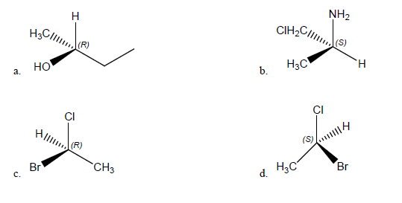
4. Which of the following structures are meso compounds?

6. Assign R or S to the following Fischer projections:
a. 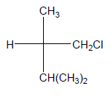 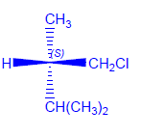
b. 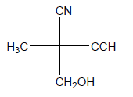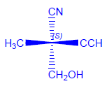
c. 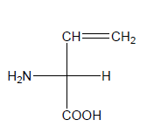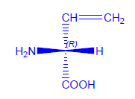
7. For the following compounds determine:
a. enantiomer pairs A & C, B & D
b. diastereomer pairs A&B, A&D, B&C, C&D
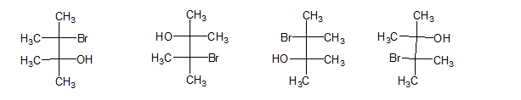
A. B. C. D.

