Newman Projections

- Which of the following would have the lowest boiling point?
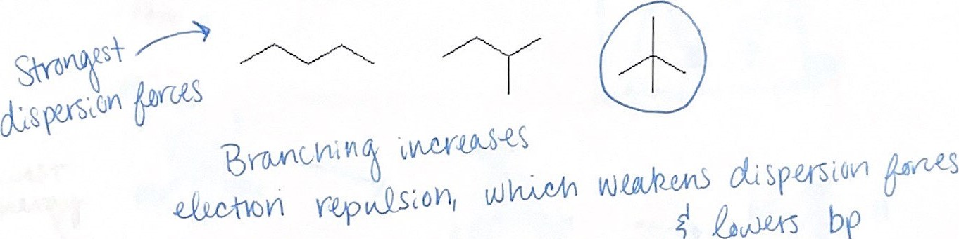
- Define the following terms.
  - Conformations – Temporary molecular shapes that result from rotation about a single bond.

  - Conformer – Each possible conformation structure
  - Conformational Analysis – Analysis of energy changes that occur as a molecule undergoes rotations about a single bond.

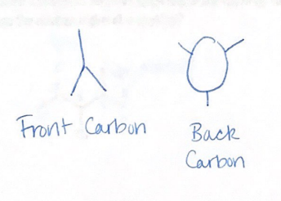
- Explain how a Newman projection is set up.
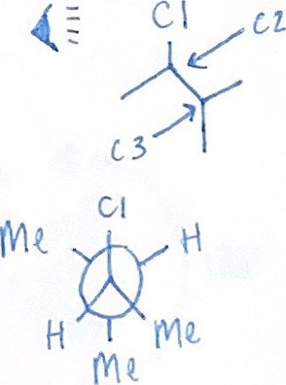

- Draw the Newman projections for the C2-C3 bond of 2-bromo-3-fluoro-2-methylpentane. Which conformations have the highest and lowest amounts of repulsive energy?

