Chair Conformations

- Explain why cyclopropane, cyclobutane and cyclopentane are less stable than cyclohexane.

- Give the relative bond angles of cyclopropane, cyclobutane and cyclopentane.

- What are the main 2 conformations of cyclohexane, and which is the most stable? Why is one more stable than the other?

- What is the difference between the equatorial and axial substituents of the cyclohexane conformations?

- Draw the following structures. Where appropriate, label the substituents as either axial or equatorial.
  - Trans-1,2-dimethylcyclobutane

  - Trans-1,2-dimethylcyclohexane

  - Cis-1,2-dimethylcyclohexane

  - Trans-1,3-dimethylcyclohexane

- Draw the most stable conformation of the following structures.
  - Trans-1-t-butyl-4-methylcyclohexane

  - Cis-1-t-butyl-4-methylcyclohexane

- Name the following structures. If it is not the most stable conformation, draw one that is.
a)
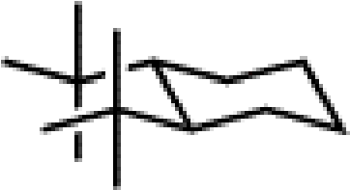

b) 