What is meant by having a chiral center? What atoms possess this type of stereochemistry? Can a carbon with a double bond be chiral?

List the priority for the following groups in decreasing order:
a. –CH3 –CH₂CH₃ –CH=CH₂

b. –OH –CH(OH)H₃ –CH₂OH –COOH

c. –CH₂NH₂ –NO₂ –C≡N –NH₂

Assign R and S to each of the following:
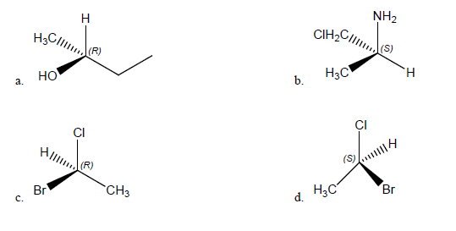

Which of the following structures are meso compounds?

6. Assign R or S to the following Fischer projections:
a. 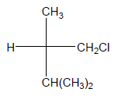
b. 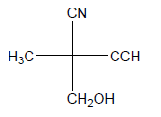
c. 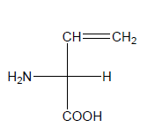

7. For the following compounds determine:
a. enantiomer pairs
b. diastereomer pairs
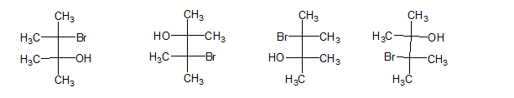
A. B. C. D.

