Analyze the reaction(s) and reaction conditions, then predict the structure of the major organic product and indicate the predominant mechanism (S_{N}1, S_{N}2).
1.
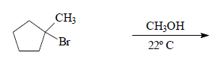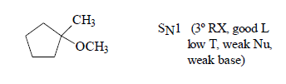

2.
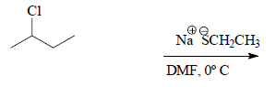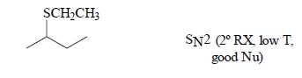

3.
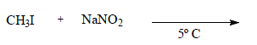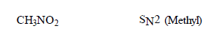

4.
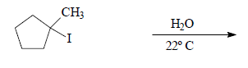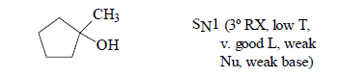

5.
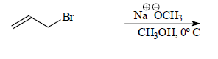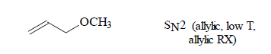

1. 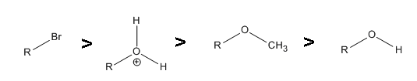
2. An S_{N}1 reaction would occur faster in H₂O because it's polar protic and would stabilize the carbocation and CH₃CN is polar aprotic.
3. Polar aprotic solvents, a weak leaving group and primary substrates disfavor S_{N}1 reactions.
4. 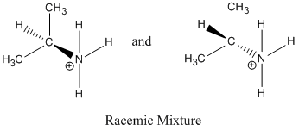
Reaction proceeds via SN1 because a tertiary carbocation was formed, the solvent is polar protic and Br- is a good leaving group.
5. You could change the solvent to something polar aprotic like CH3CN or DMSO and you could use a better base for a nucleophile such as NH₂- or OH-.
6. 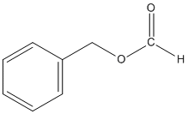
This reaction occurs via S_{N}1 because Cl⁻ is a good leaving group and the solvent is polar protic. This is an example of a solvolysis reaction because the nucleophile is also the solvent.

