Worksheet 9: Functional Groups

1. What functional groups are present in each molecule below?

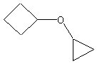

6. The alcohol below is classified as which of the following?
a. | primary alcohol | c. | tertiary alcohol
b. | secondary alcohol | d. | aromatic alcohol

Circle and name the functional groups in the following molecules (not including cyclic Carbon ring in first molecule)

a.

b.

3. How many functional groups and different hydrocarbons can you spot in each molecule?

a. b.

c. d.

f.

