1. Write the electron configuration for Co.

2. What element is depicted by this orbital notation?

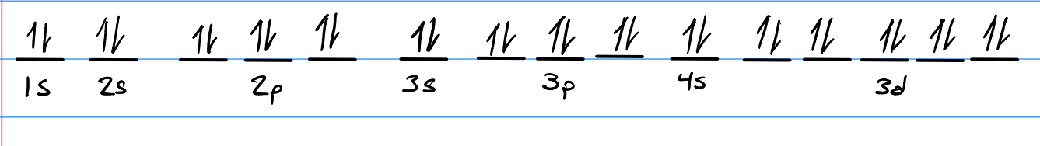

3. For the following elements / ions, write down the electron configuration & the number of valence electrons.

Element/Ion | Electron Configuration | Valence Electrons
F
C
Si
Mn
Be
Ne
Al
O

