Analyze the reaction(s) and reaction conditions, then predict the structure of the major organic product and indicate the predominant mechanism (S_{N}1, S_{N}2).
1.
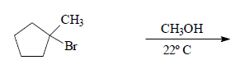

2.
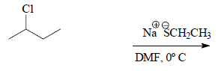

3.
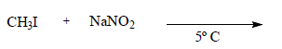

4.
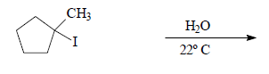

5.
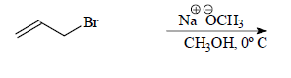

1. Put the following leaving groups in order of decreasing leaving group ability
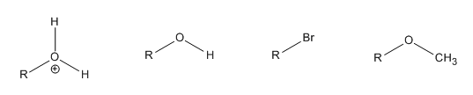
A. B. C. D.
2. Which solvent would an SN1 reaction occur faster in? H₂O or CH₃CN

3. What kind of conditions disfavor S_{N}1 reactions?

4. What are the products of the following reaction and does it proceed via S_{N}1 or S_{N}2?
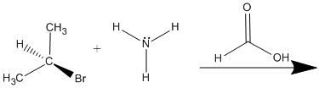
5. How could you change the reactants in the problem 4 to favor the other substitution reaction?

6. Indicate the expected product and list why it occurs through S_{N}1 instead of S_{N}2?
