Worksheet 7- Cis and Trans Compounds/hybridization

- What is the purpose of having specific bond angles?

- How many electron domains will you find in the following molecular geometries, of the central element?
What should be the bond angles in each molecular geometry around the central element?
What is the hybridization of each geometry?
Draw an example of each one.

- Tetrahedral

- Trigonal Planar

- Linear

- Bent/Angular

- Trigonal pyramidal

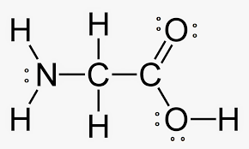
- How much s and p character are present in the central element of this compound (the carbon)?

- Determine if the following compounds are cis or trans:

