Chair Conformations

- Explain why cyclopropane, cyclobutane and cyclopentane are less stable than cyclohexane.


- Give the relative bond angles of cyclopropane, cyclobutane and cyclopentane.
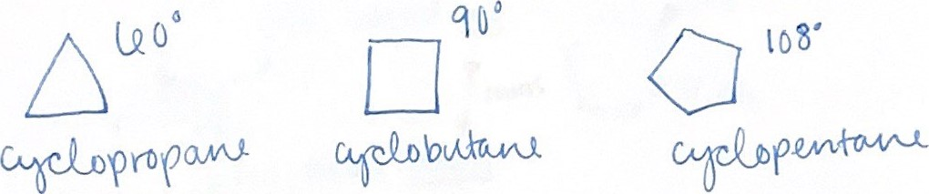
- What are the main 2 conformations of cyclohexane, and which is the most stable? Why is one more stable than the other?
Chair and Boat conformation, chair conformation is more stable than the boat conformation because the Newman Projection for the chair conformation is staggered (lower potential energy) and the Newman projection for the boat conformation is eclipsed (higher potential energy).
9) What is the difference between the equatorial and axial substituents of the cyclohexane conformations?
Axial substituents are vertically oriented, equatorial substituents are angled slightly. Equatorial substituents are more stable in this position then in an axial position. The larger a substituent is the more stable it will be then in an equatorial position.
- Draw the following structures. Where appropriate, label the substituents as either axial or equatorial.
  - Trans-I,2-dimethylcyclobutane
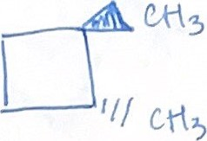
  - Trans-I,2-dimethylcyclohexane
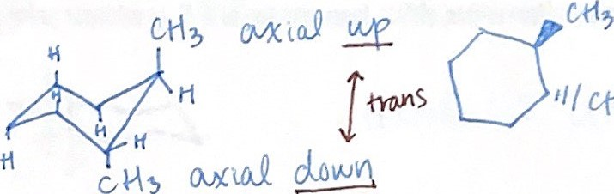

  - Cis-I,2-dimethylcyclohexane
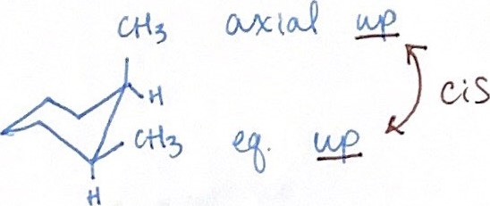
  - Trans-I,3-dimethylcyclohexane
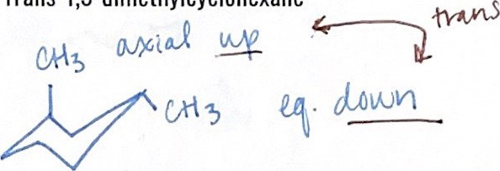
- Draw the most stable conformation of the following structures.
  - Trans-I-t-butyl-4-methylcyclohexane
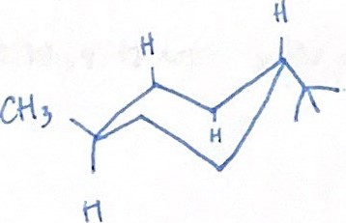
  - Cis-1-t-butyl-4-methylcyclohexane
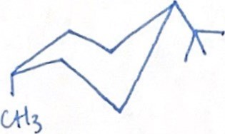
- Name the following structures. If it is not the most stable conformation, draw one that is.
a)

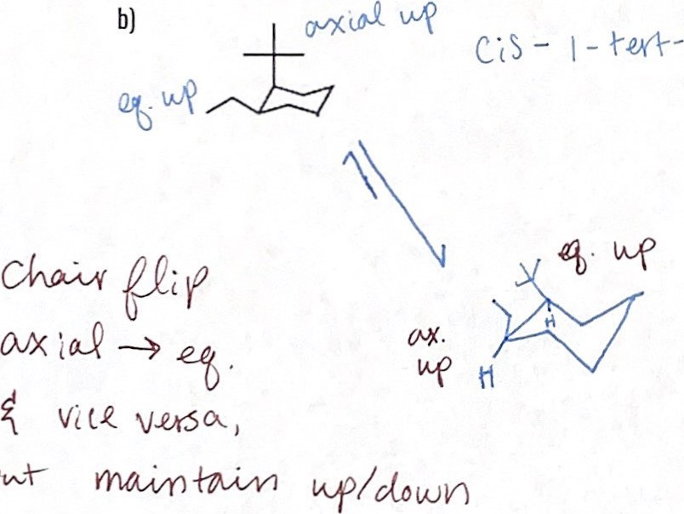

Cis-1-tert-butyl-2-ethylcyclohexane

